1. Multivariable Norma monte carlo

Widely used in risk management.

1. simulate K random draws from a N variables distributed multivariable normal

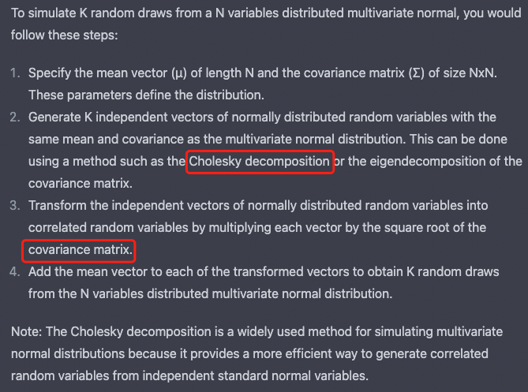

1. Cholesky decomposition: for PD and PSD matrix.
2. Missing data
3. Covariance matrix generation techniques

1. Exponentially Weighted Covariance
2. Dealing with non-PSD Matrices
3. Principal Component Analysis